**Restaurant Management**

## Table of Contents

Abstract 2

Acknowledgment 2

List of Figures......................................................................................................................................... 4

List of Tables.......................................................................................................................................... 5

1.0 Overview ......................................................................................................................................... 6

1.1 Problem Statement ........................................................................................................................ 7

1.2 Approach ........................................................................................................................................ 8

2.0 Requirement Analysis Process ........................................................................................................ 9

2.1 Functional Requirements............................................................................................................... 10

2.2 Nonfunctional Requirements......................................................................................................... 11

2.3 Use Case Diagrams......................................................................................................................... 12

2.4 Use Case Descriptions ................................................................................................................... 13

3.0 Materials Used .............................................................................................................................. 14

3.1 Methodology ................................................................................................................................. 15

3.1.1 Software Development Methodology......................................................................................... 16

3.2 Database development…………………………………………………………………………...................................... 17

3.3 Interface Design.............................................................................................................................. 18

3.4 User Interfaces................................................................................................................................ 19

3.5 System Design..................................................................................................................................20

References............................................................................................................................................ 21

**Use case Diagram**

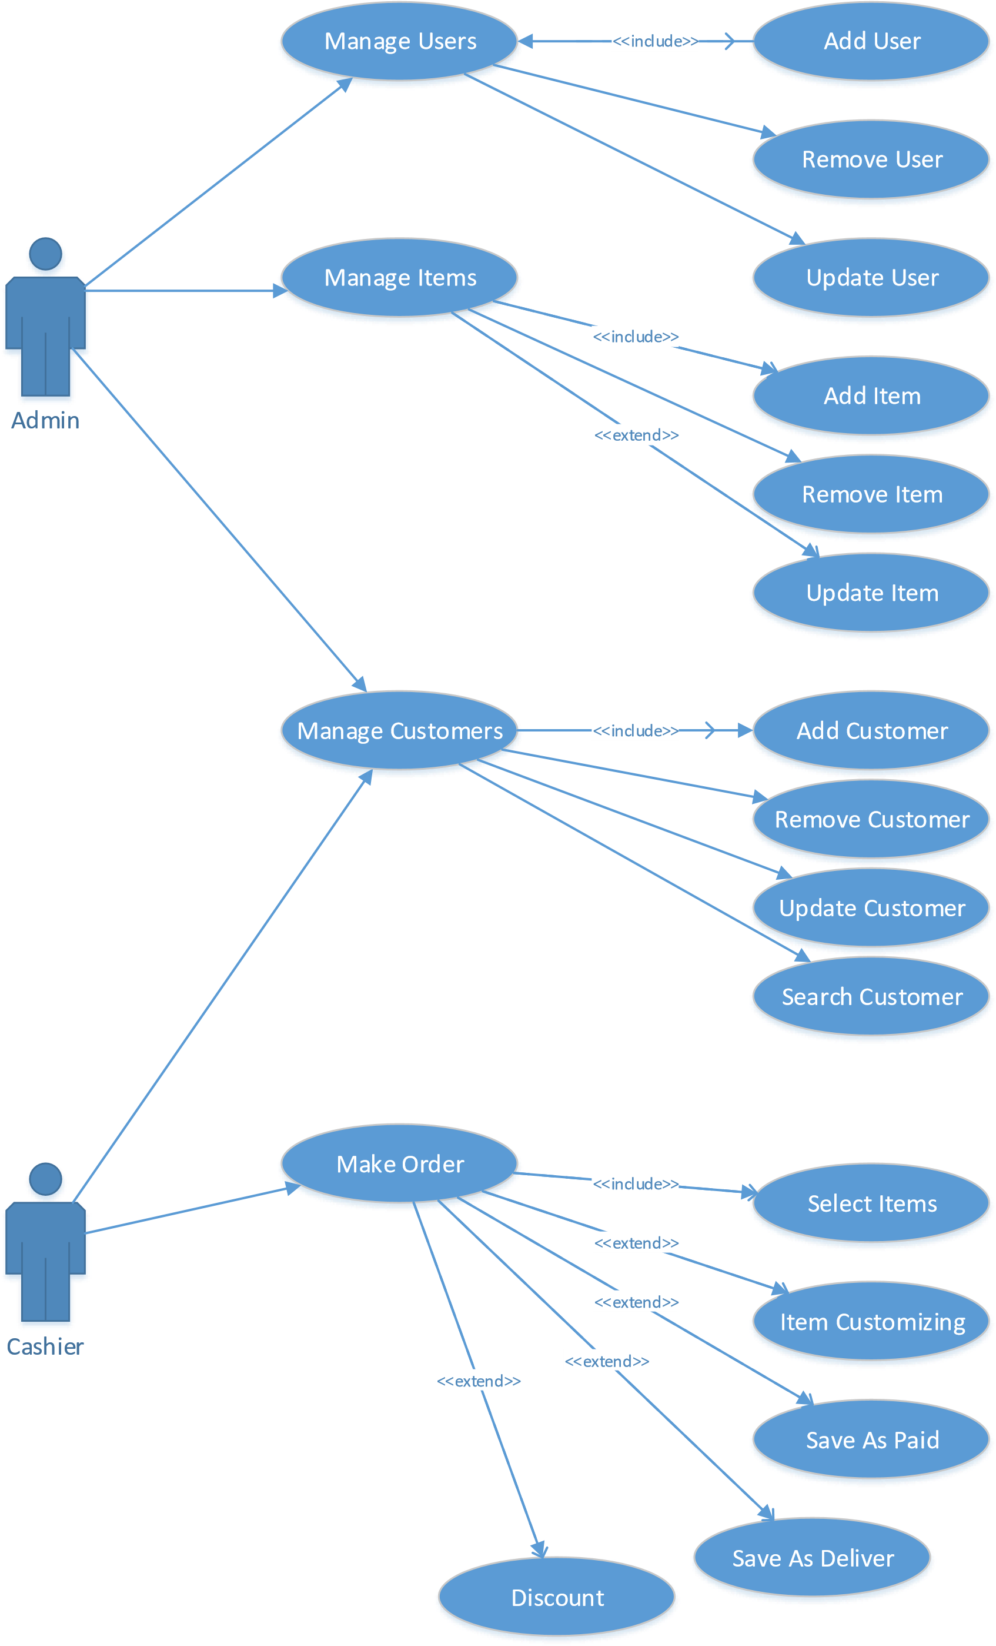

**ERD**

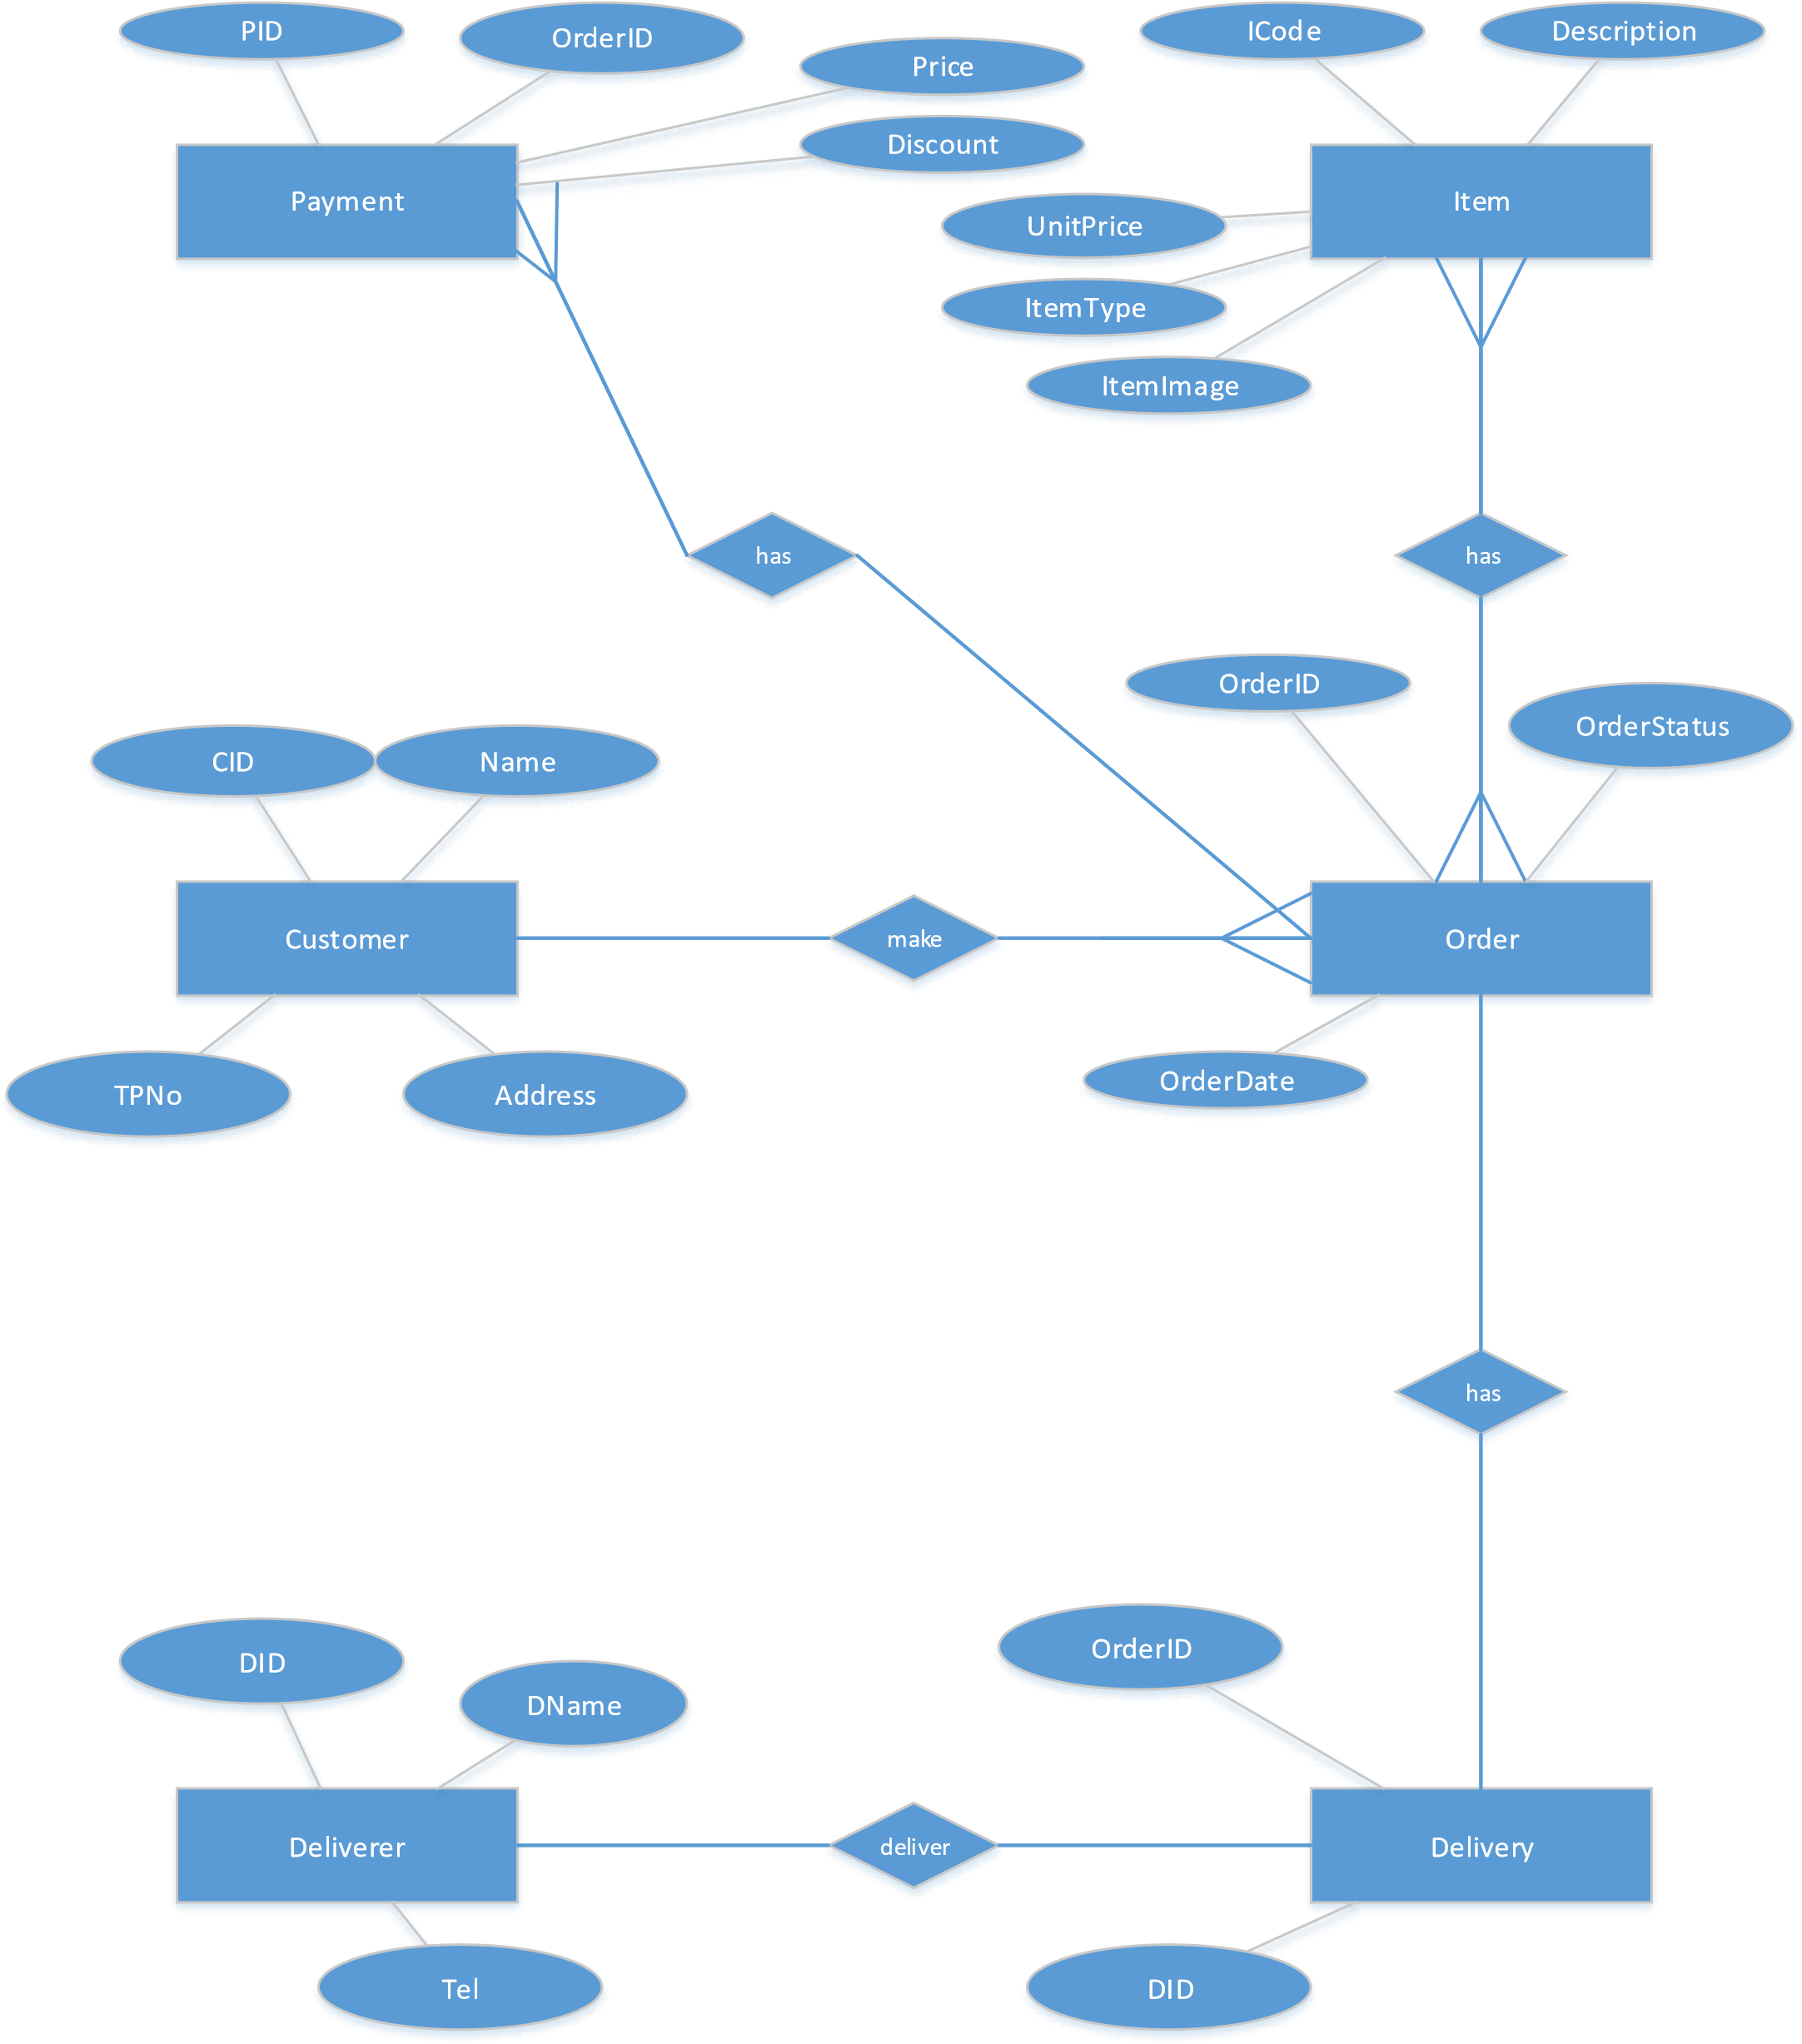

**Logical Schema**

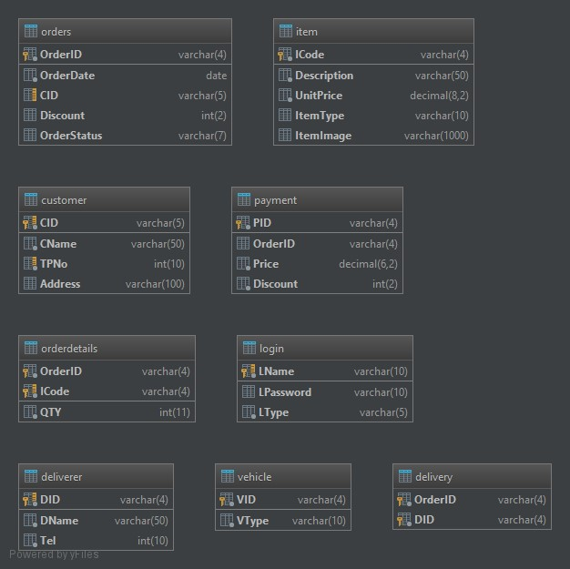

**User Interfaces**

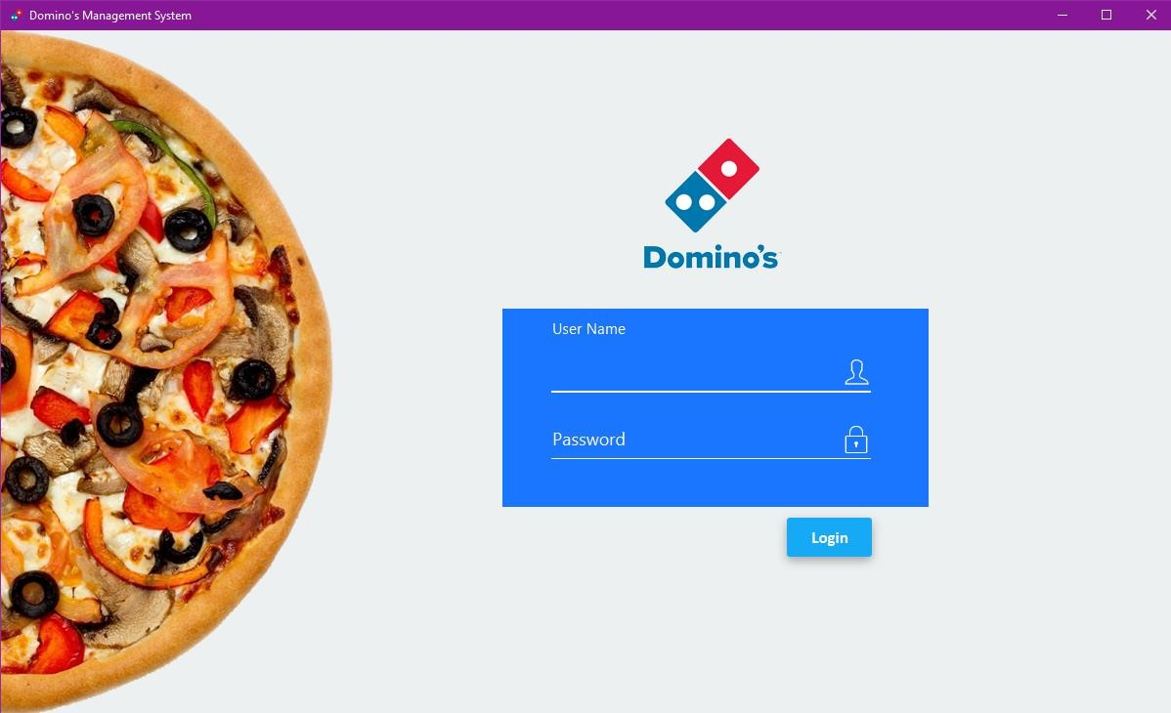

|  |  |
| --- | --- |
| Use Case Name | User Login |
| Actor Involved | Admin or Cashier |
| Description | Registered users log in to the system using their login credentials. |
| Precondition | The user should have a valid user account before login & user privileges are depend on account type |
| Flow of Events | * Go to login window * Enter user name and Password * Then the system checks the username and password with registered user information * If user login details are valid, create a home page based on user’s user roles. * If username and password are not valid user will get an error message. |

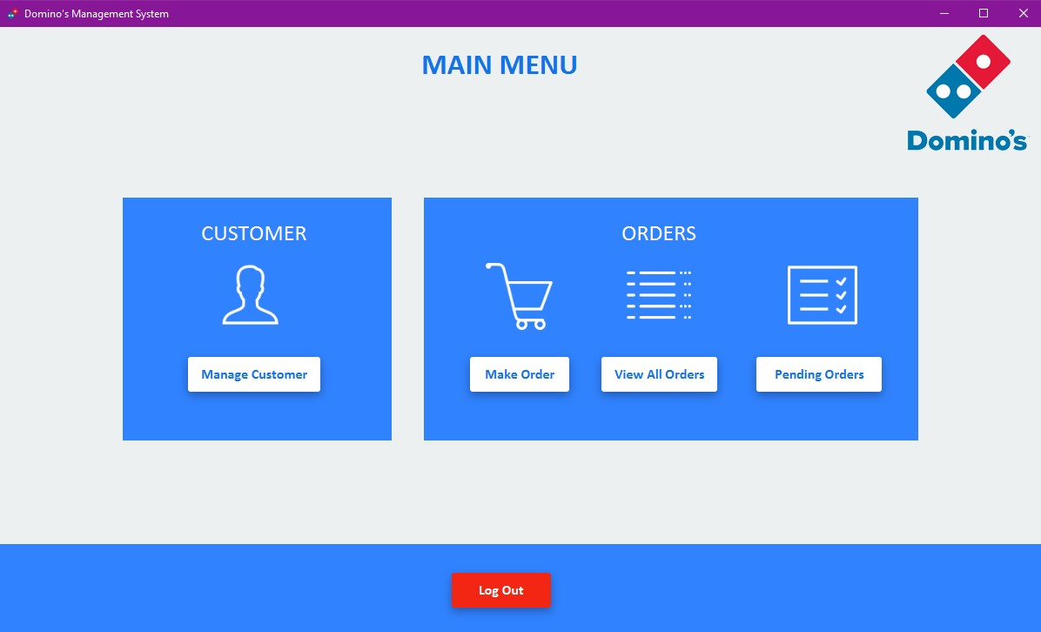

|  |  |
| --- | --- |
| UI Name | Cashier Main Menu |
| Actor Involved | Cashier |
| Description | This window shows for cashier only |
| Precondition | The Cashier should have privileges to go selected window |
| Flow of Events | * Go to cashier main menu window * Select one (Click) * Then the system goes to selected window |

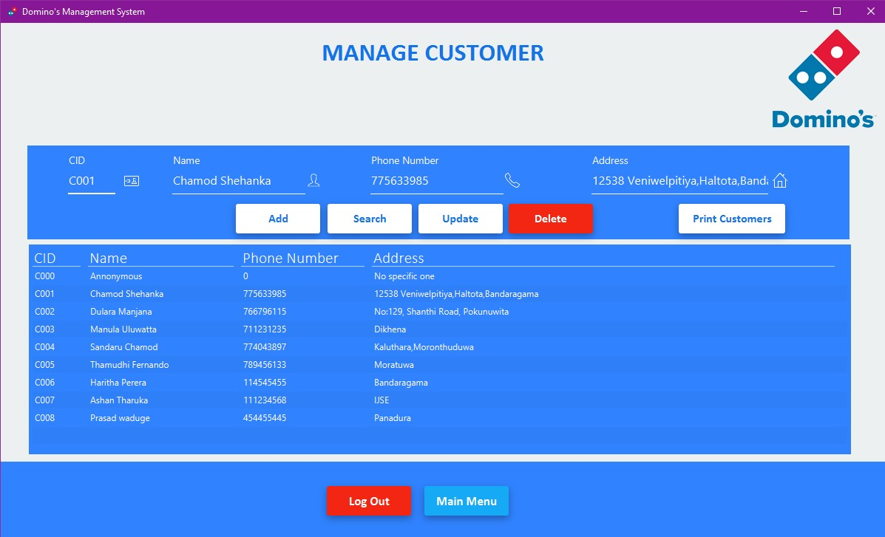

|  |  |
| --- | --- |
| UI Name | Manage Customer |
| Actor Involved | Cashier or Admin |
| Description | User can add, search, update and delete customers |
| Precondition | The Cashier should have privileges to manage customers and print all customers |
| Flow of Events | * Go to manage customer window * Search customer using CID or name * If customer not found user can add them or manage them |

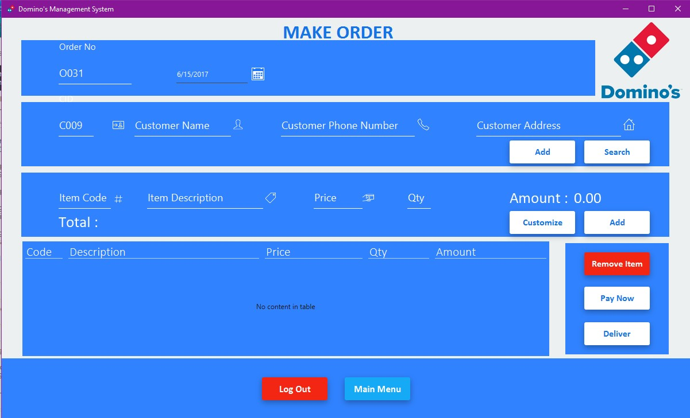

|  |  |
| --- | --- |
| UI Name | Make Order |
| Actor Involved | Cashier |
| Description | User can make order and customize order |
| Precondition | Cashier should have search customer if customer not found then cashier should have added, Cashier should have search items using item code and customizing those items then pay now or deliver |
| Flow of Events | * Go to the make order window * Search customer or add customer * Then search items and input qty then user can customize each item via customizing window * If order is completed user can go to next step Pay Now or Deliver |

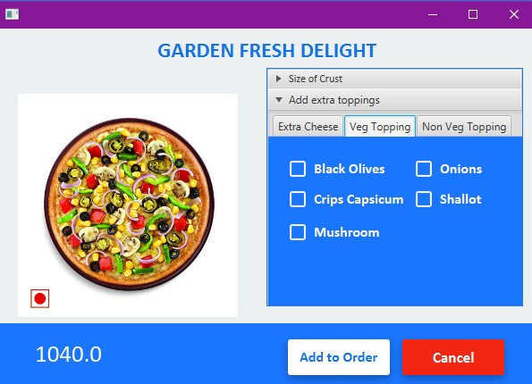

|  |  |
| --- | --- |
| UI Name | Customize Items |
| Actor Involved | Cashier |
| Description | User can customize items by customer opinions |
| Precondition | Cashier should have customized items by customer ideas and opinions |
| Flow of Events | * Go to the customize window * Click size of crust and choose one * Then click add extra toppings and select them * Now items have been successfully customized and cashier can update new details to order |

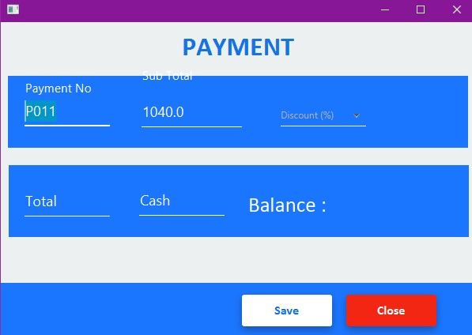

|  |  |
| --- | --- |
| UI Name | Payment |
| Actor Involved | Cashier |
| Description | User can put discount and save order |
| Precondition | Cashier should have privileges to put discount and save order |
| Flow of Events | * Go to the payment window * Select discount * Then total is visible * Now cashier can input customer’s cash amount and view balance * Finally, cashier can save order |

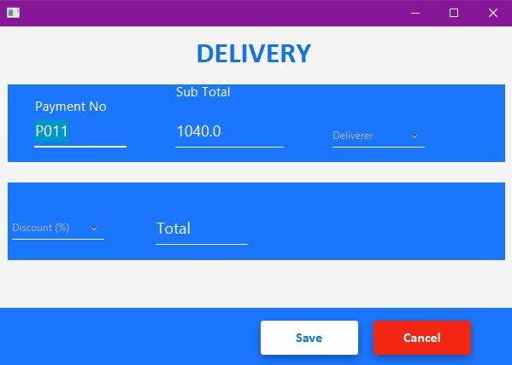

|  |  |
| --- | --- |
| UI Name | Delivery |
| Actor Involved | Cashier |
| Description | User can put discount and save order |
| Precondition | Cashier should have privileges to put discount and save order |
| Flow of Events | * Go to the payment window * Select deliverer * Select discount * Then total is visible * Now cashier can input customer’s cash amount and view balance * Finally, cashier can save order |

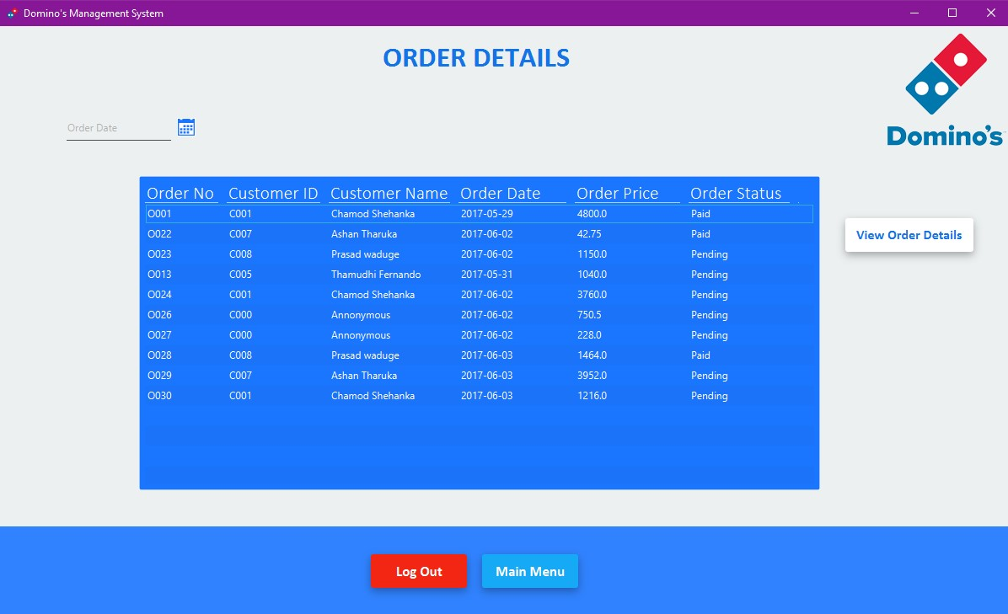

|  |  |
| --- | --- |
| UI Name | Order Details |
| Actor Involved | Cashier & Admin |
| Description | User can view orders day by day & can view orders detail by each order |
| Precondition | User should have privileges to view orders all of time and day by day |
| Flow of Events | * Go to the order details * Select row * Click view order details * Then View Order Details window is visible |

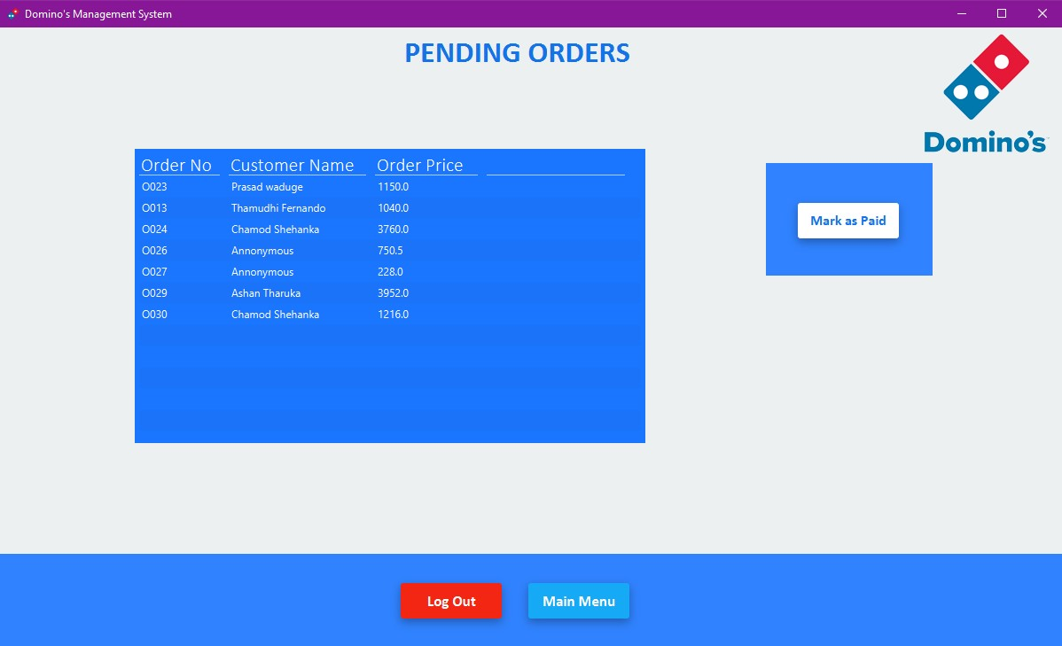

|  |  |
| --- | --- |
| UI Name | Pending Orders |
| Actor Involved | Cashier & Admin |
| Description | User can view pending orders and can mark as paid each order (Pending orders means order added but not yet paid, delivering orders) |
| Precondition | User should have privileges to view pending orders and mark as paid |
| Flow of Events | * Go to the pending orders * Select row * Click Mark as Paid * Then selected order is paid order and it hide from pending orders table |

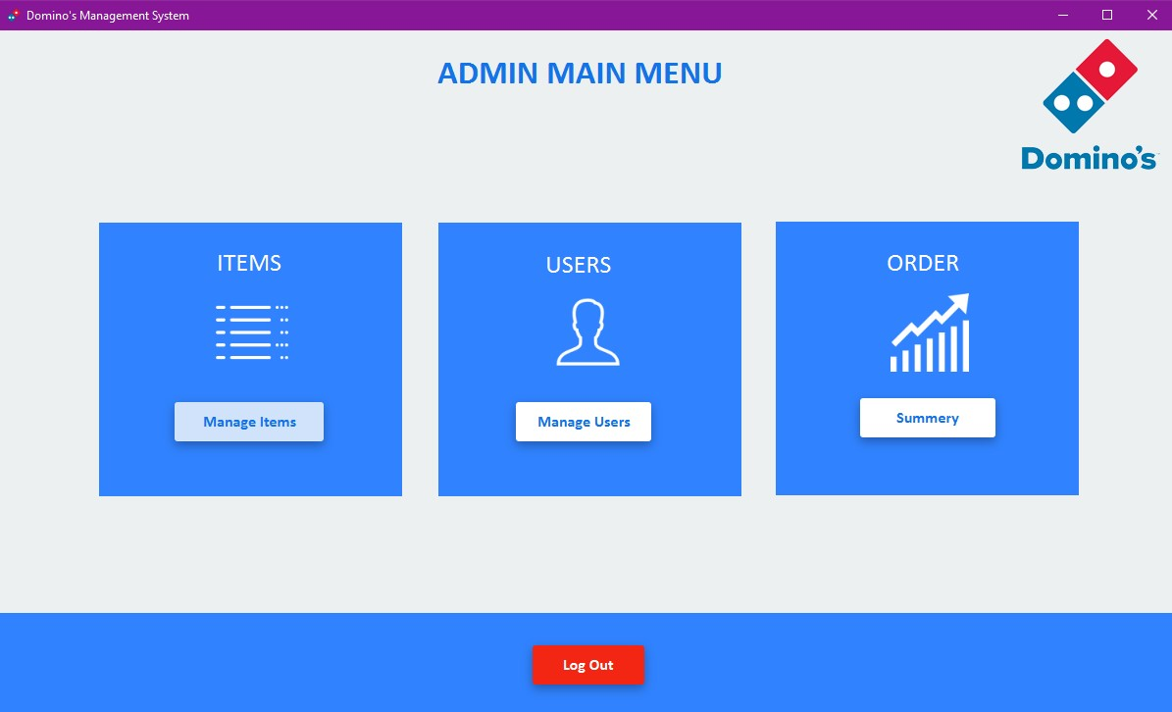

|  |  |
| --- | --- |
| UI Name | Admin Main Menu |
| Actor Involved | Admin |
| Description | This window is shows admin only |
| Precondition | Admin should have privileges to select what him came for and select one |
| Flow of Events | * Go to admin main menu window * Select one (Click) * Then the system goes to selected window |

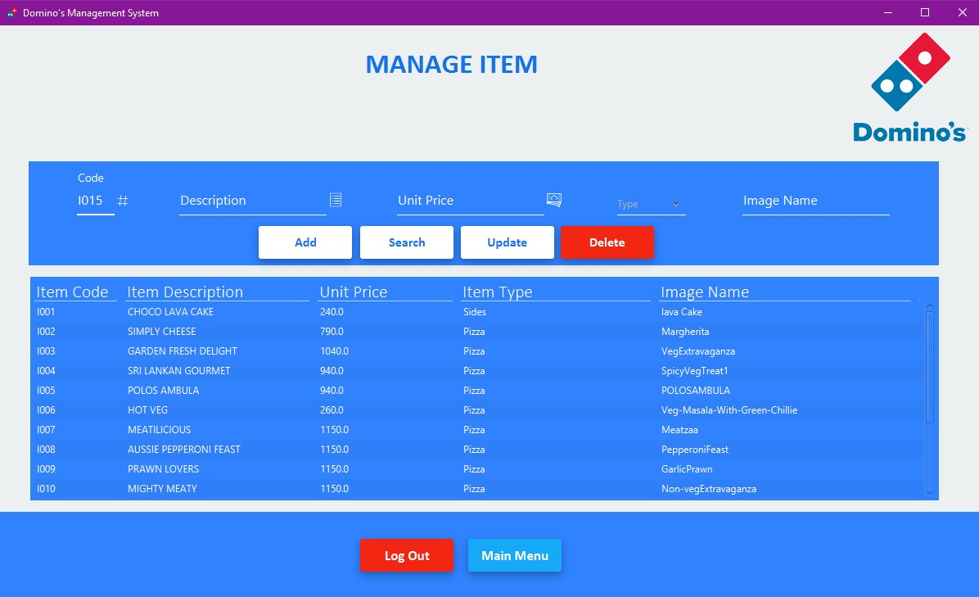

|  |  |
| --- | --- |
| UI Name | Manage Item |
| Actor Involved | Admin |
| Description | This window is shows admin only and admin can add, search, update, delete items |
| Precondition | Admin should have privileges to add items, update item, delete item and search item |
| Flow of Events | * Go to manage item window * Search item via item code or manage item |

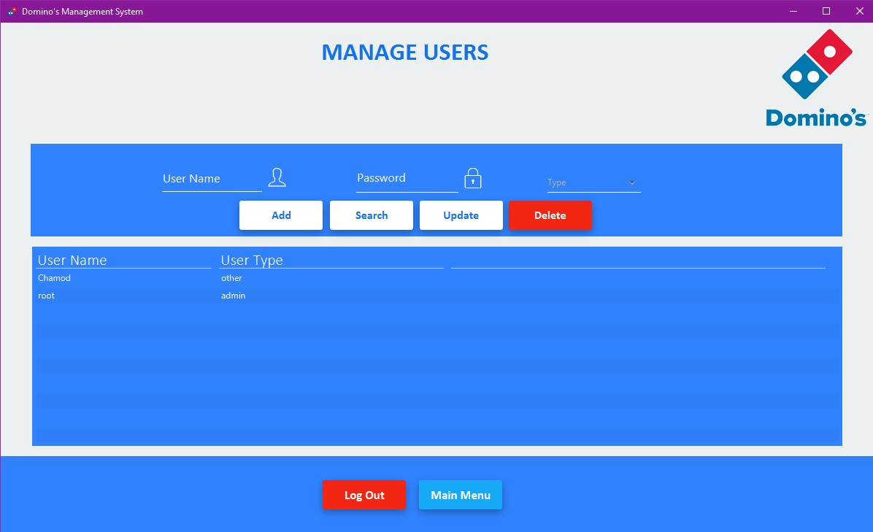

|  |  |  |
| --- | --- | --- |
| UI Name | Manage Users | |
| Actor Involved | Admin | |
| Description | This window is shows admin only and admin can add, search, update, delete users | |
| Precondition | Admin user | should have privileges to add user, update user, delete user and search |
| Flow of Events | ➢ | Go to manage user window |
|  | ➢ | Insert User Name |
|  | ➢ | Insert Password |
|  | ➢ | Choose account type |
|  | ➢ | Then Add |

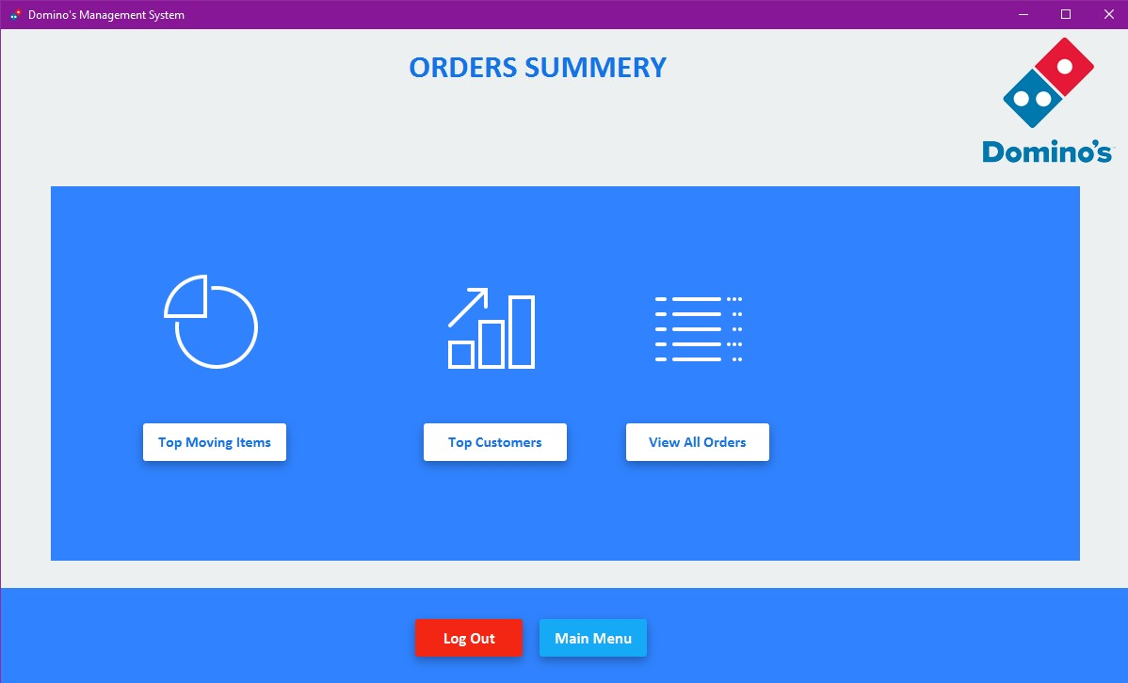

|  |  |
| --- | --- |
| UI Name | Order Summery |
| Actor Involved | Admin |
| Description | This window is shows admin only and admin can view orders summarizations |
| Precondition | Admin should have privileges to view order summarizations |
| Flow of Events | * Go to order summery * Insert User Name * Select one and click |

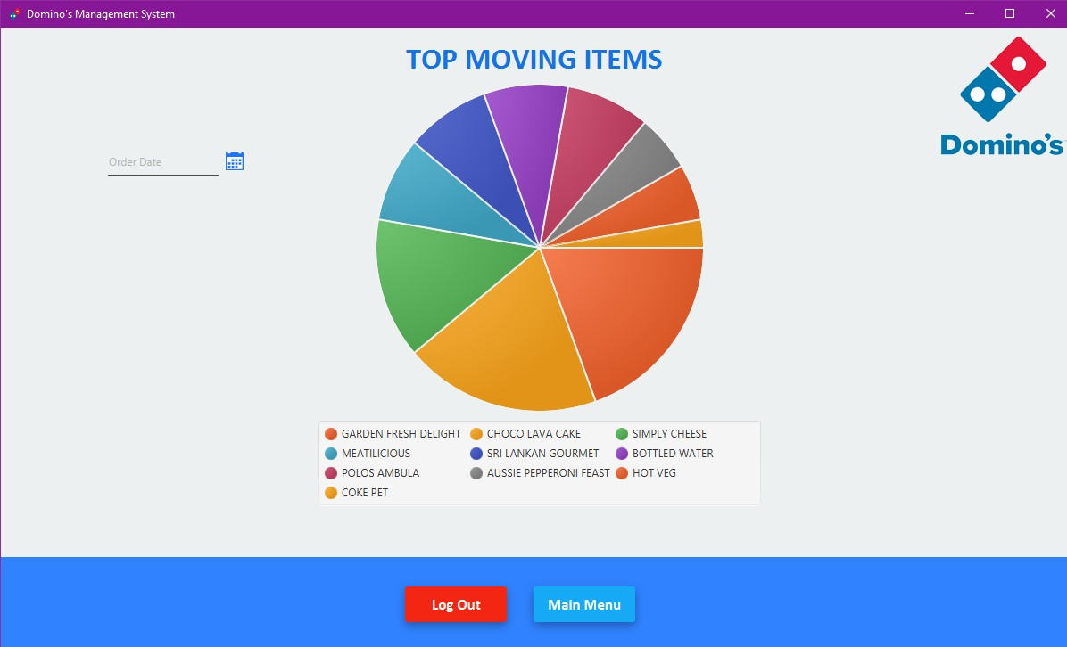

|  |  |
| --- | --- |
| UI Name | Top Moving Items |
| Actor Involved | Admin |
| Description | This window is shows admin only and admin can view top moving items all of time and day by day |
| Precondition | Admin should have privileges to view order summarizations |
| Flow of Events | * Go to order summery * Select top moving item * Then user can see top moving item all of time and user can view it as day by day using date picker |

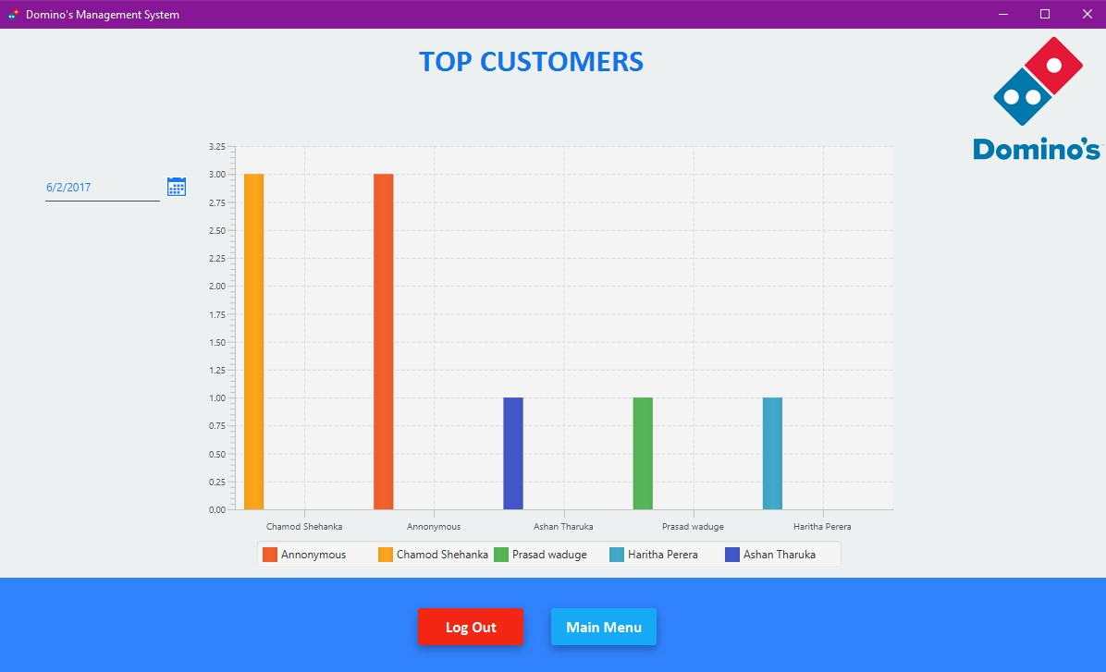

|  |  |
| --- | --- |
| UI Name | Top Customers |
| Actor Involved | Admin |
| Description | This window is shows admin only and admin can view top customers all of time and day by day |
| Precondition | Admin should have privileges to view order summarizations |
| Flow of Events | * Go to order summery * Select top customers * Then user can view top moving item all of time * Then user can change it to day by day using date picker |

## Security features of the software

* User privilege parameters:

User privilege parameters are used to personalize features and

security to individual users or user roles. These user privilege parameters are saved to a user’s profile and accessible throughout every application.

Why is this so important? User privilege parameters are incredibly flexible. They can control an application’s look and feel, add or hide user options, limit user capabilities, and more.

* Data Base Backup & Restore ➢ Users passwords protection